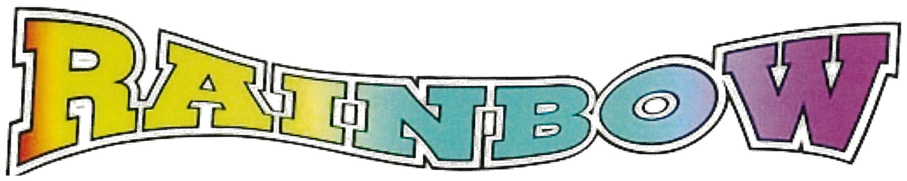
PRINTING & OFFICE SUPPLY
(775) 831-2276 • FAX (775) 831-5535
917 TAHOE BLVD., SUITE 103 • BOX 5488 • INCLINE VILLAGE, NV 89451
Personal Label Printing
Printed on Avery 5160 White Label - 30 on a Page
Quantity Printed Labels | Black Ink | Color Ink
120 Finished Labels 4 sheets Includes Type/Set-Up | $17.56 | $20.60
250 Finished Labels 9 sheets Includes Type/Set-Up | $25.76 | $32.59
500 Finished Labels 16 sheets Includes Type/Set-Up | $37.23 | $49.37
1000 Finished Labels 34 sheets Includes Type/Set-Up | $54.99 | $80.80
Extra Charges for Clear Label Stock Per Sheet | $1.50 | $1.50
Add a Logo Extra Charge | $5.00 | $5.00
Any Other Avery Label Template Extra Charge | $10.00 | $10.00
Misc. Art Work Charges | Estimate | Estimate
Prices Do Not Include Sales Tax
Turnaround Time - Same or Next Day

